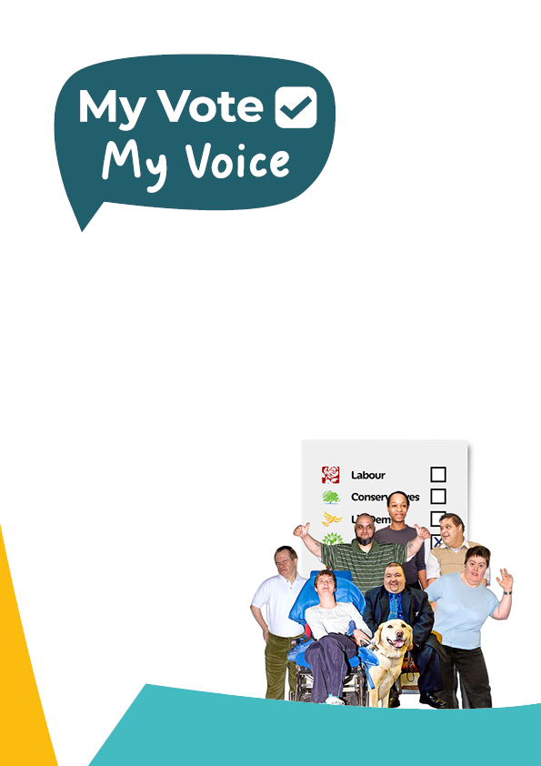

Your easy read guide to making accessible documents
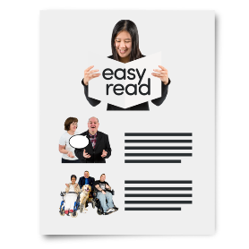 | Easy read is a way of putting information across is an easy to understand way.
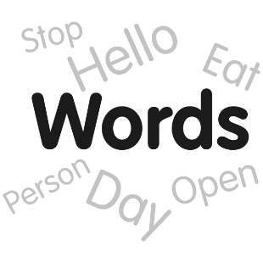 | It puts the important information in plain English.
 | And has images to help show what it written.
 | Sentences should be kept short.
 | And addressed to you, the reader.
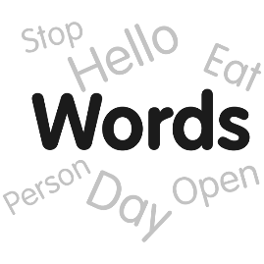 | Use simple words.
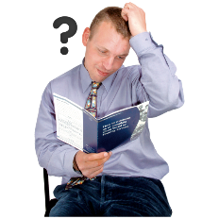 | But if a difficult word is needed put it in bold.
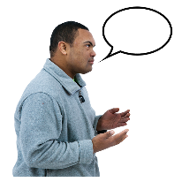 | And use the next box to explain what the difficult word means.

  Don’t | Only use full names and phrases.
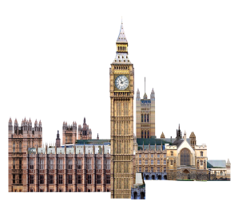 | Such as Houses of Parliament instead of HoP.
Do not | And ‘Do not’ instead of ‘Don’t’.
  One | Use numbers not words.
1 | Such as ’1’ instead of ‘one’.
 | And try not to use big numbers.
Many | Instead, say ‘many’, ‘few’ or ‘most’.
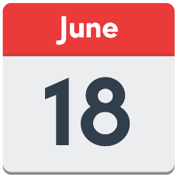 | And write the date as day (number) and Month.

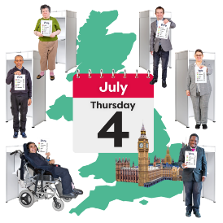 | For example, the general election is on 4 July 2024.
  : * !  # % ~ | Tips for punctuation:  - Use capitals to start a sentence or names only.  - Don’t use colons semi-colons or hyphens.  - Commas and full stops are ok.  - But don’t use too many.  - Use plain bullets for lists.  - But try not to make lists too long.
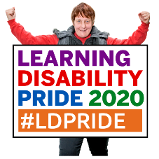  Can  Help | Use positive language.
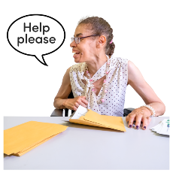 | For example, say ‘someone can help you fill out this form’  instead of  ‘you do not have to fill out this form on your own’.
 | Use one clear image for each sentence.
 | And make sure they are copyright free.
 | Photosymbols are best if you have an account.
 | If you do not, Pixabay has a lot of options.

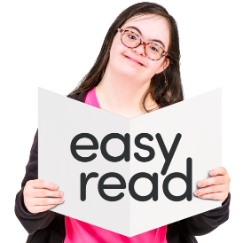 | Easy read documents can look like they are long.
 | But they are easier to read.
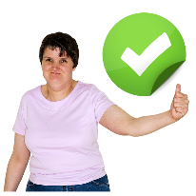 | And many people prefer them.
 | You are being inclusive by publishing easy read documents.
 | Inclusive means you are making sure more people can be involved.
 | Especially people with learning disabilities.
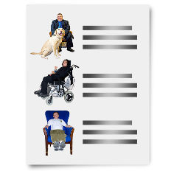 | There are lots of easy read documents for you to look at.
 | Please visit the My Vote My Voice website for lots more information.
 | If you have questions, please email  info@myvotemyvoice.org.uk

